Restaurant Management System

Our project is structured into two modules: Admin and Customer, each with its own routing files to provide a seamless user experience.

**Admin Functions:**

- Secure Authentication: Admin can log in to generate tokens and access authenticated APIs. We've implemented JWT authentication and authorization to ensure robust API protection.

- Category Management: Admin can effortlessly post, get, and search for categories, making menu management a breeze.

- Product Management: Admin have full control over products, with the ability to post, update, delete, get, and search for items on the menu.

- Reservation Requests: Admin can view reservation requests from customers and take action, such as approving or disapproving requests, to efficiently manage table bookings.

**Customer Functions:**

- Secure Authentication: Customers can log in to generate tokens and access authenticated APIs, just like admin. JWT authentication and authorization are in place to safeguard data and functionality.

- Product Browsing: Customers can explore all the products available on the menu directly from their dashboard.

- Product Search: Easily find specific products with a convenient search feature.

- Reservation Requests: Customers can initiate reservation requests to secure a dining table for a specific date and time.

- Past Reservation Requests: Customers can also access their history of reservation requests for reference.

sequence diagrams

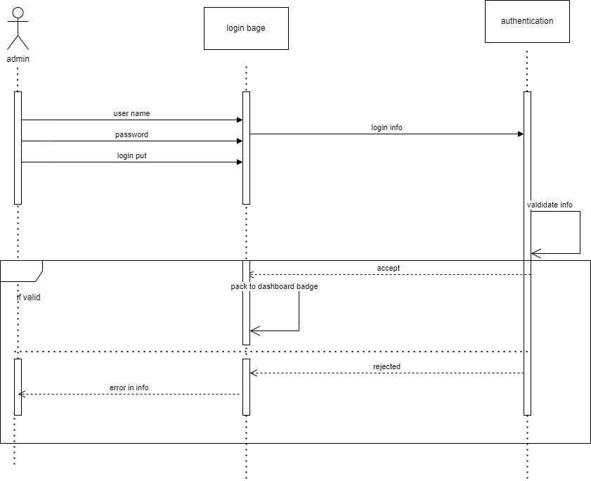

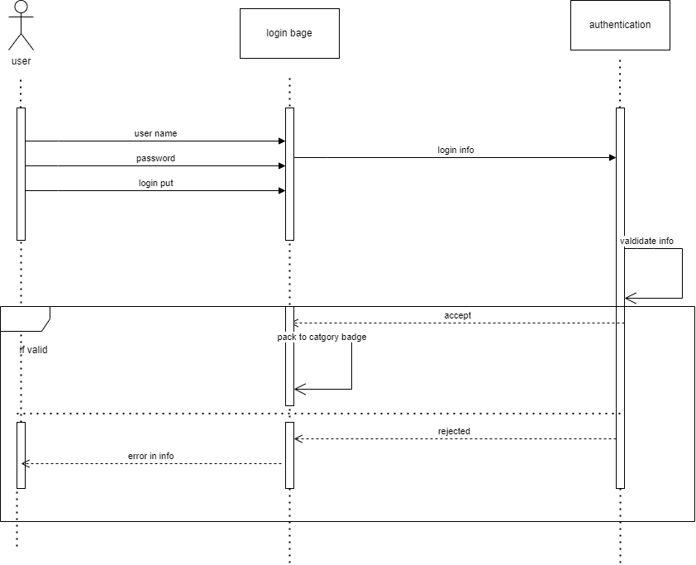

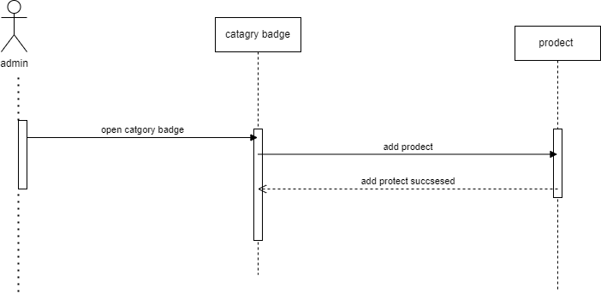

Use Case diagram

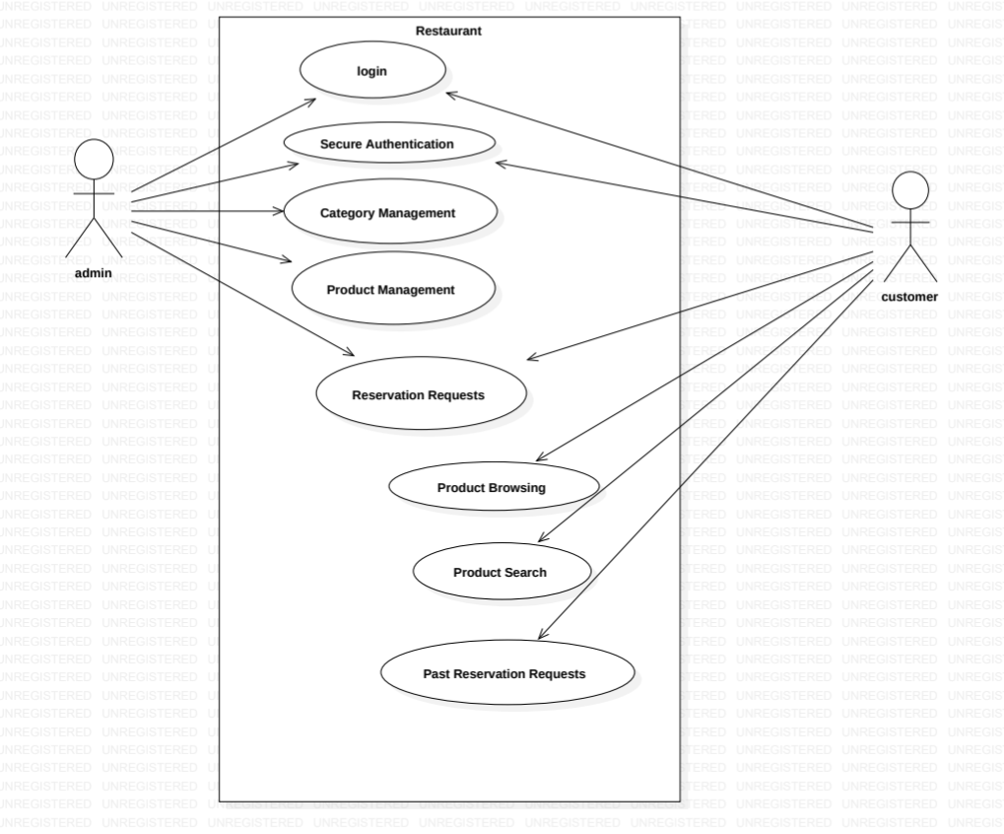

ERD

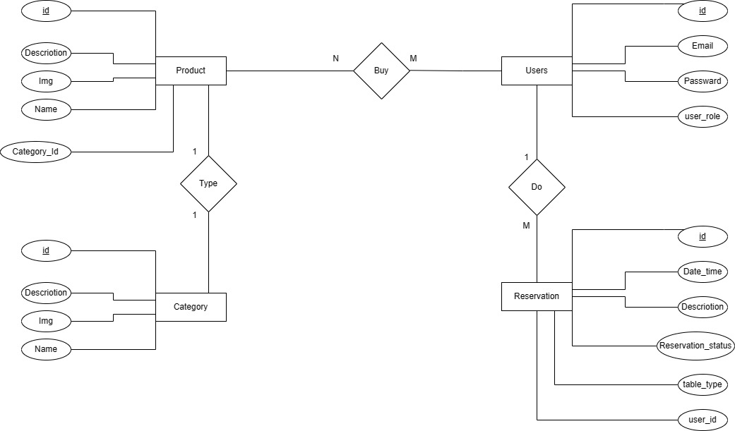

OCL